**Installation Prerequisites**

## **TaskT**

## **Pre-requisites:**

* Open Google Chrome.
* Browse url https://github.com/saucepleez/taskt/releases/tag/v3.5.0.0.
* Click on ‘[taskt.v3.5.0.0.zip](https://github.com/saucepleez/taskt/releases/download/v3.5.0.0/taskt.v3.5.0.0.zip)’ in bottom.

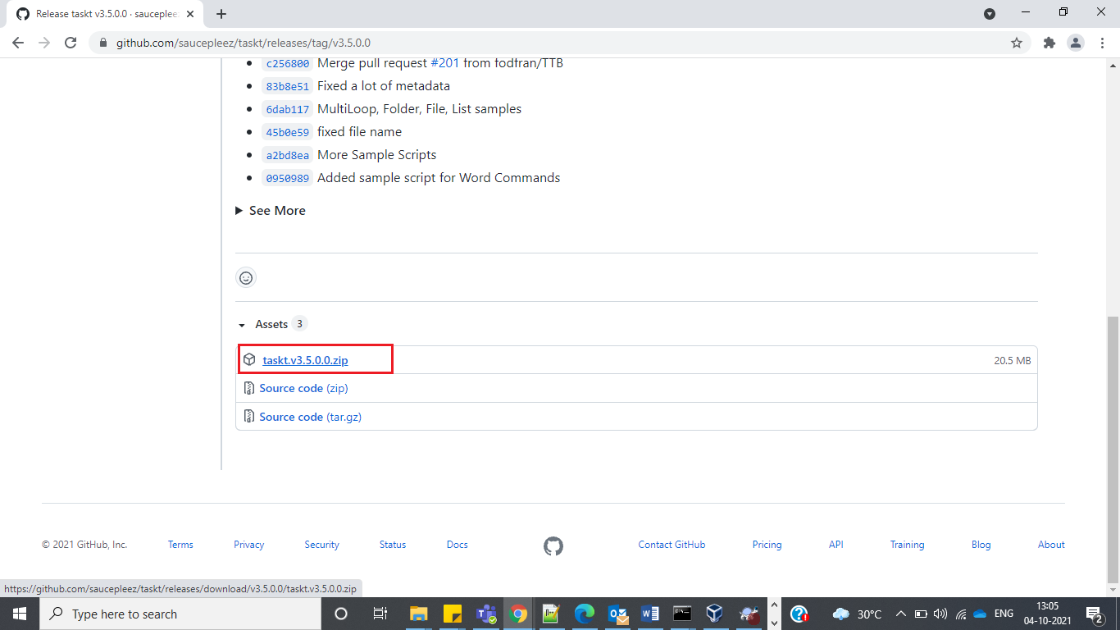

## **Installation:**

* Navigate to the directory where ‘[taskt.v3.5.0.0.zip](https://github.com/saucepleez/taskt/releases/download/v3.5.0.0/taskt.v3.5.0.0.zip)’ is downloaded.
* Right click on the ‘[taskt.v3.5.0.0.zip](https://github.com/saucepleez/taskt/releases/download/v3.5.0.0/taskt.v3.5.0.0.zip)’ and click on ‘Extract All’.
* Select the destination directory<install_dir> and click on ‘Next’ button.
* Navigate to the ‘<install_dir>\taskt.v3.5.0.0\Release’, then click on ‘taskt.exe’.
* After the click, ‘Unable to locate script folder’ window will be opened. Click on Yes button.

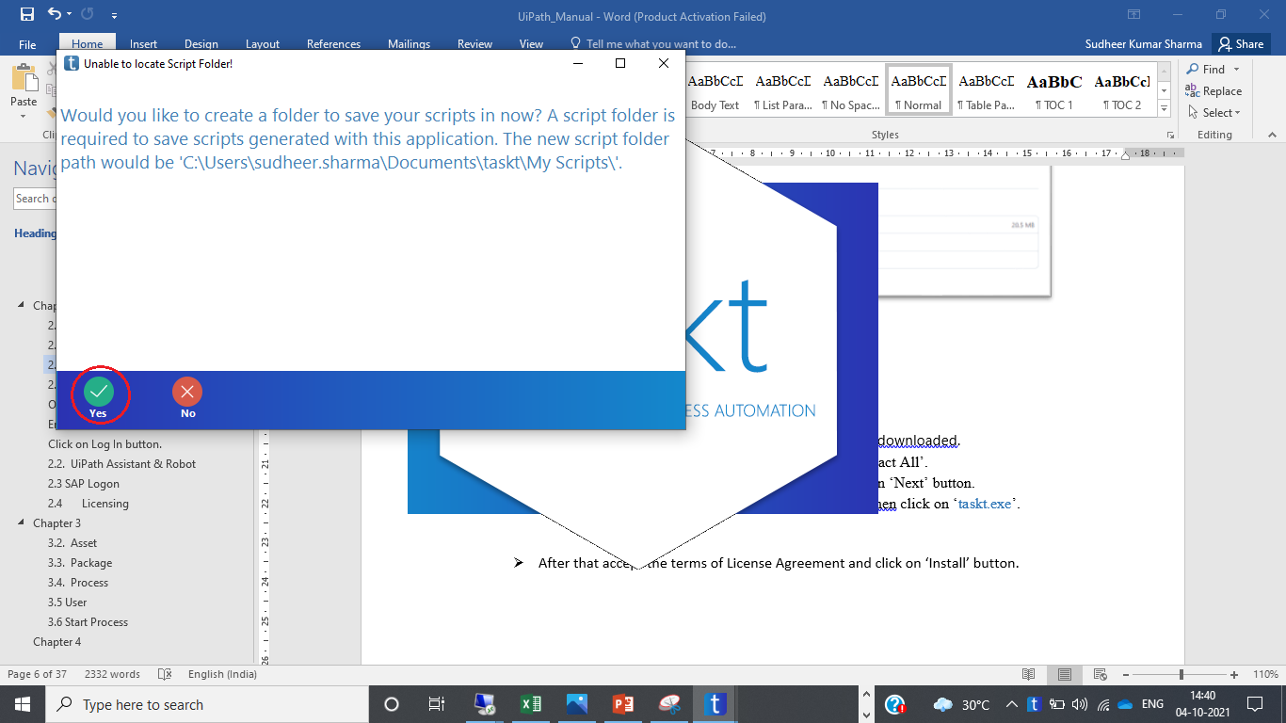

* Now TaskT installed successfully and TaskT window is opened.

**2.1.3 Verification**

* Expand on ‘Folder Operation Commands’ from the right pane and double click on ‘Create Folder’.

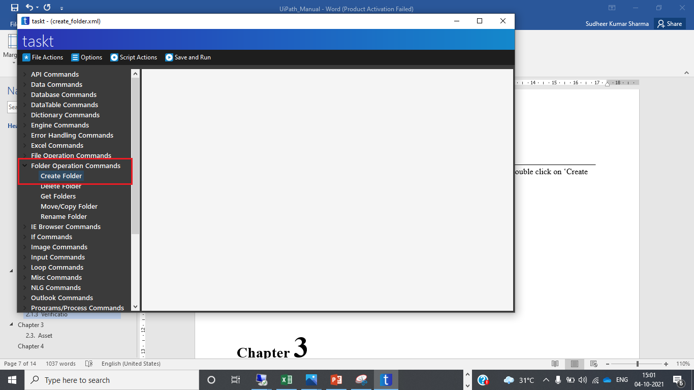

* After that a new window will be opened. Fill the below details:
  + Select a folder = “Location where to create folder”
  + Insert Variable = “Name of the folder to be created”
* Click on ‘OK’ button.

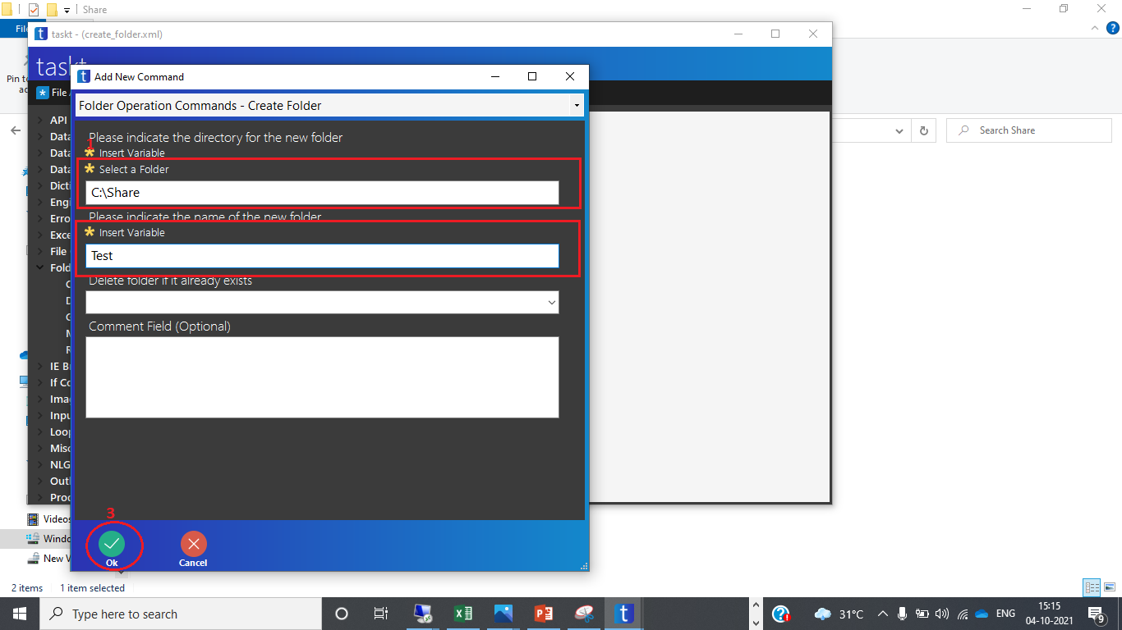

* Now Select the script from right pane that is created above and click on ‘Save and Run’ button.

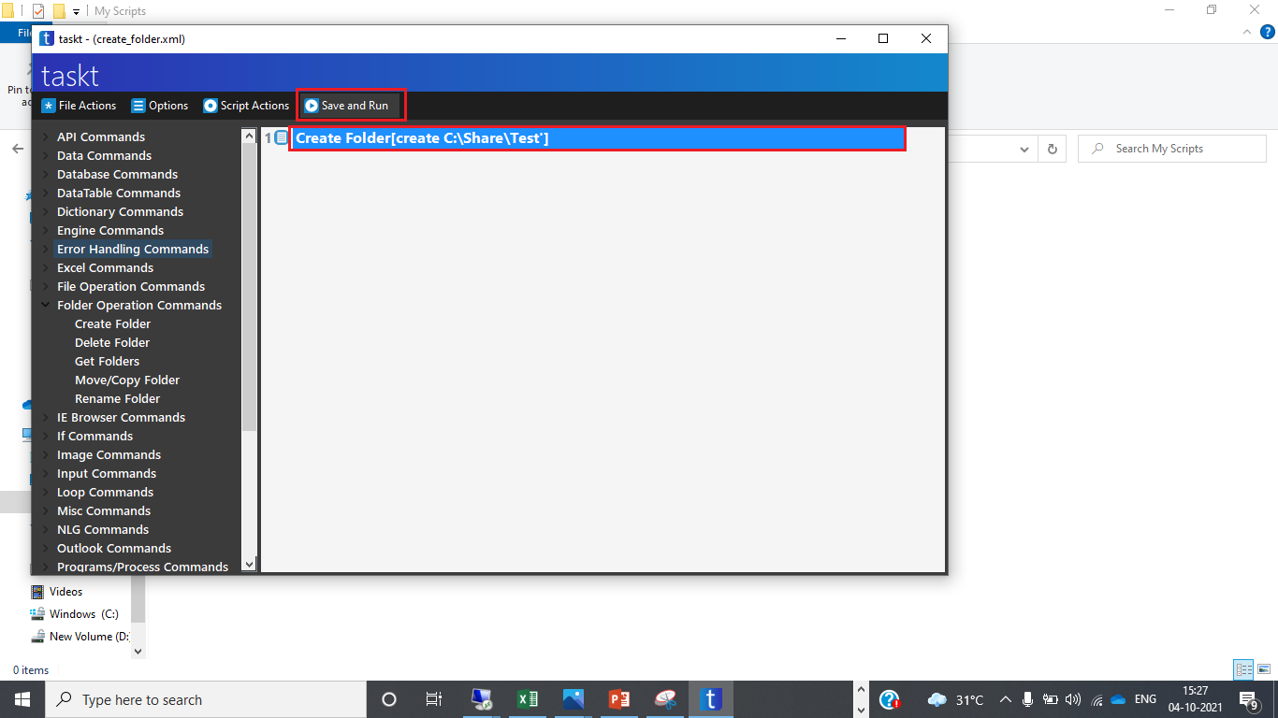

* After the click, choose the location to save the script.

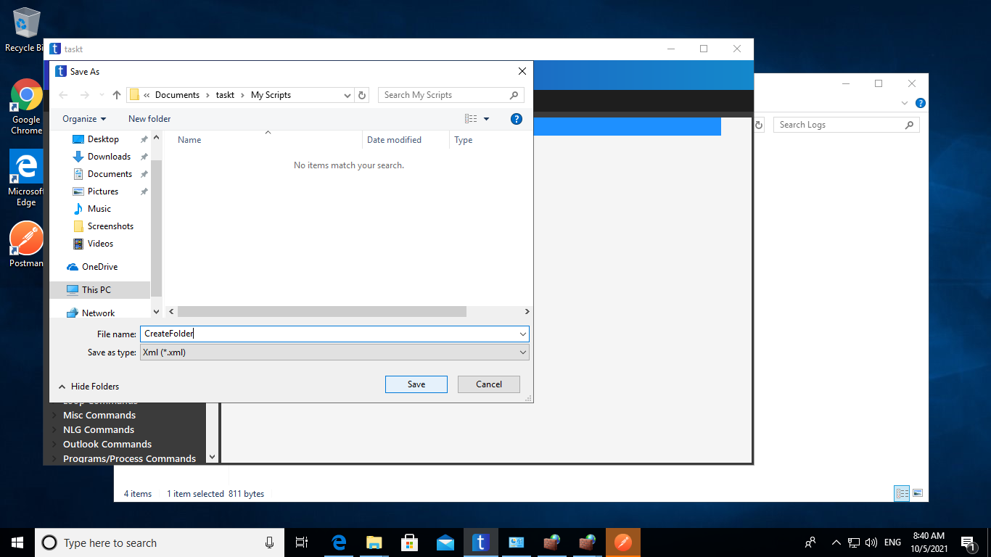

* After successfully execution of taskt verify that the folder is created on the location.

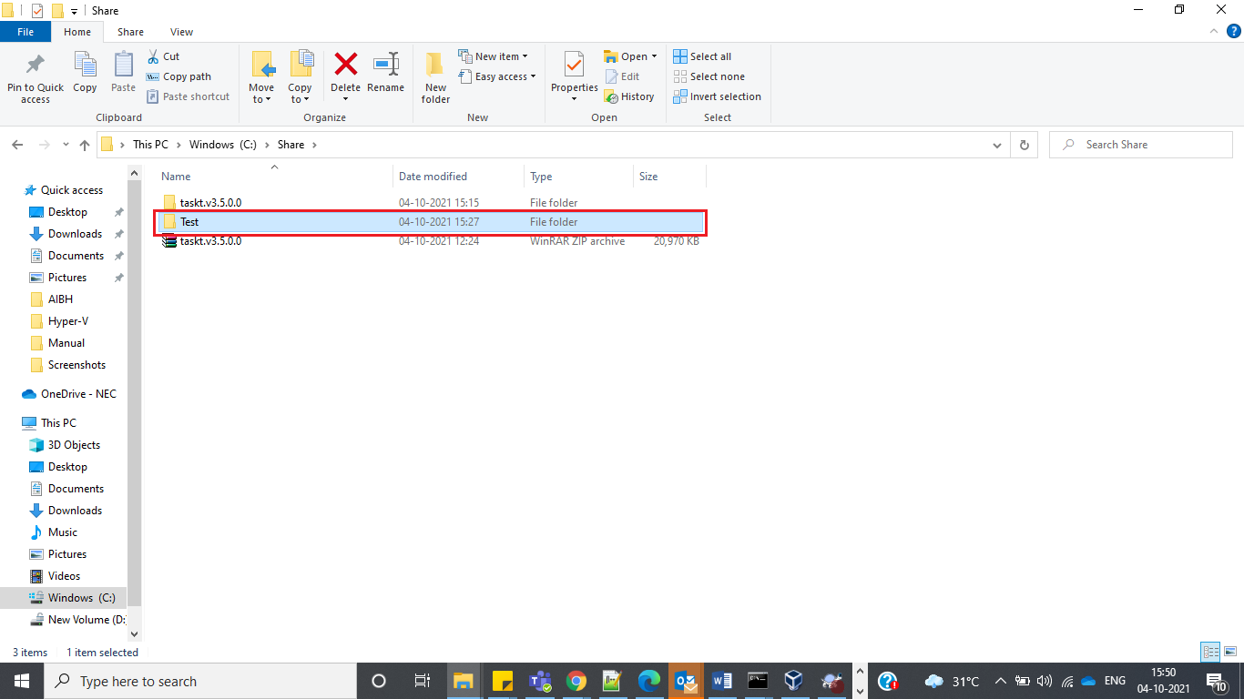

# Chapter 3

**TaskT Configuration**

# 3.1.

* 1. **Local Listener**
     1. Pre-requisites:
* Add Rule to Windows Firewall if applicable
  + Open Windows Firewall > Inbound Rules Pane > New Rule
  + Select "Port" Rule and click Next
  + Select "TCP" and Specific Local Port. Enter Port Number (19312 is default) and click Next
  + Select "Allow the Connection" and click Next
  + Select "Private" or "Domain and click Next
  + Enter a Rule Name and click Finish.
    1. Local Listener Configuration:
* Navigate to the ‘<install_dir>\taskt.v3.5.0.0\Release’, then click on ‘taskt.exe’.
* Click on ‘Options’ menu and then click on ‘Settings Manager’.

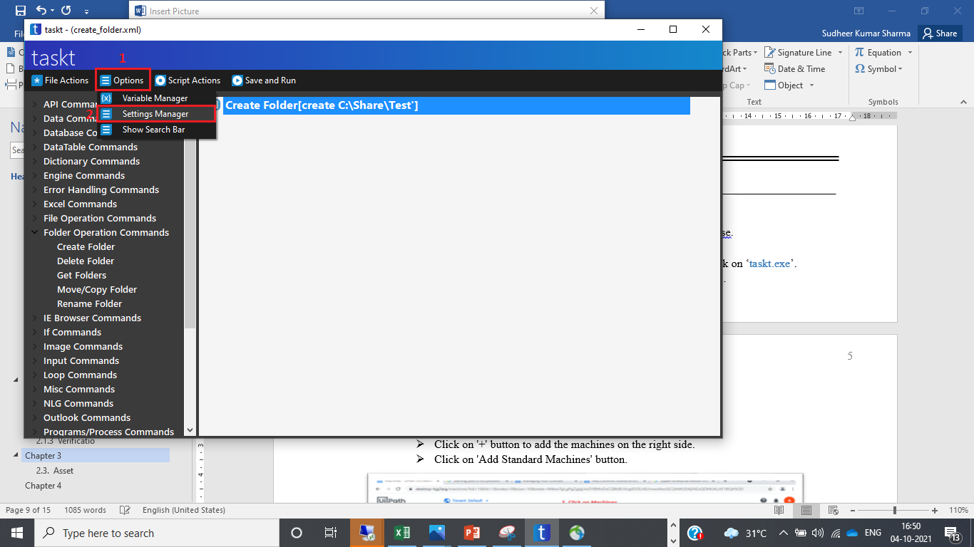

* Now ‘Settings’ window will be opened. Click on ‘Local Listener’ tab.

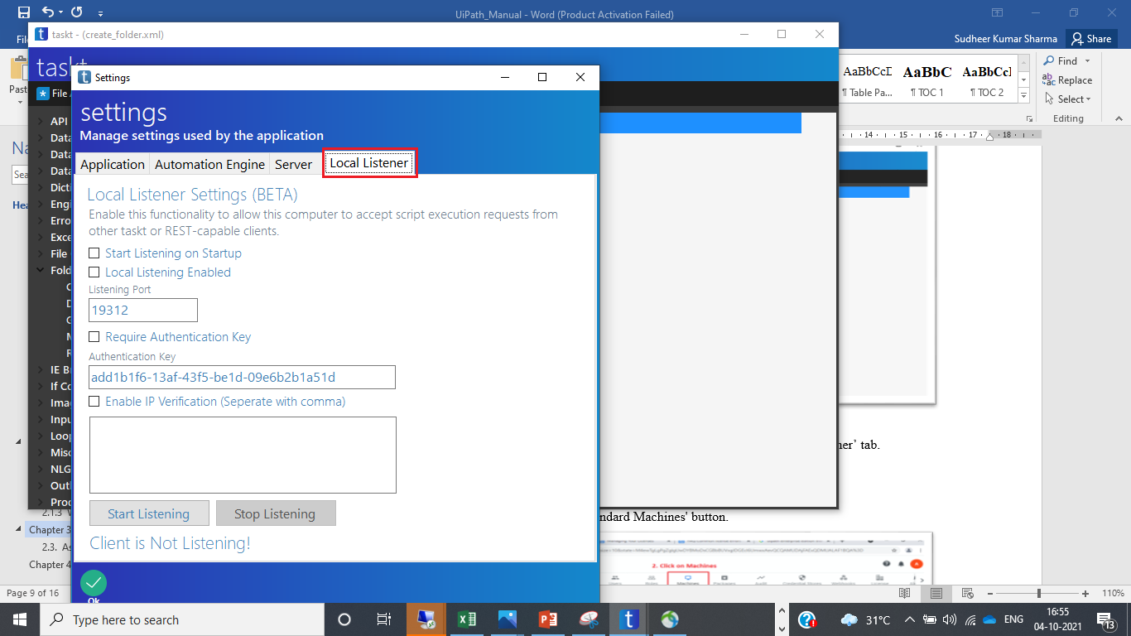

* Do the below configuration:
  + Check Start Listening on Startup.
  + Local Listening on enabled.
  + Enter Listening Port
  + Enter IP address of the host server.
* Click on ‘Start Listening’ button.

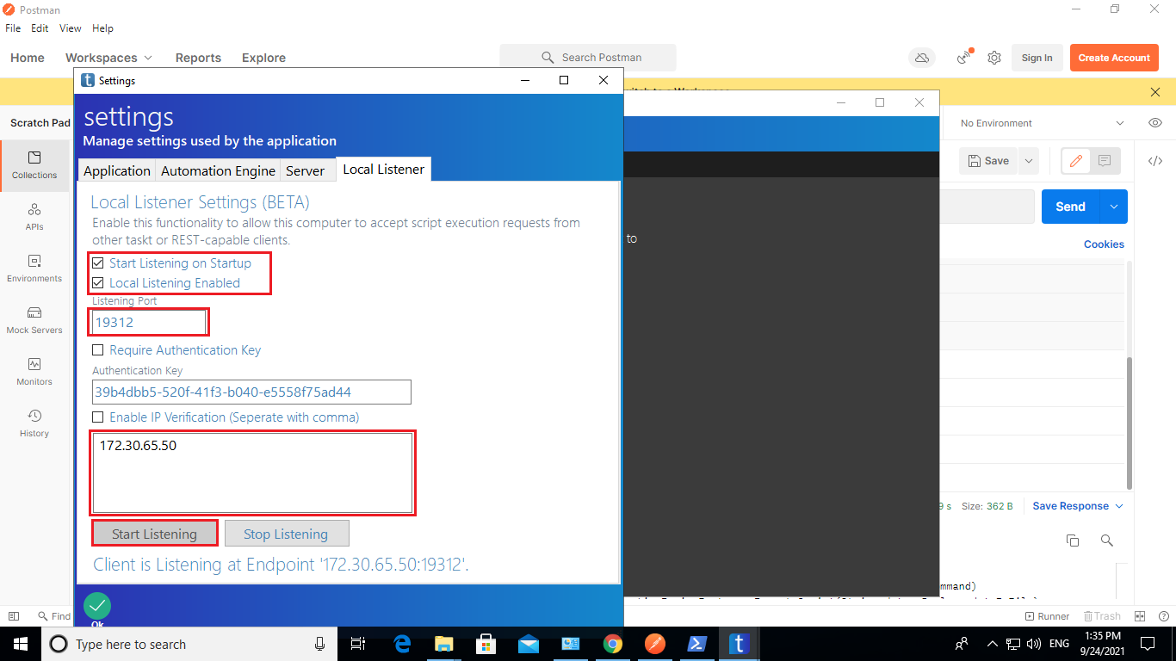

# Chapter 4

**Postman**

**4.1.**

* 1. **Pre-requisites**
* Download the ‘Postman-win64-8.11.1-Setup.exe’ file from below URL:

URL: https://dl.pstmn.io/download/latest/win64

* 1. **Installation**
* Navigate to the directory where ‘Postman-win64-8.11.1-Setup.exe’ is downloaded.
* Double click on the ‘‘Postman-win64-8.11.1-Setup.exe’.
* After sometimes is will be installed successfully.
  1. **Verification**
* Open Control Panel.
* Navigate to ‘Control Panel\Programs\Programs and Features’
* Postman-win64-8.11.1 must be present in the software list.

# Chapter 5

**Run BOT**

**5.1.**

* 1. **Pre-requisites:**
* Bot ‘CreateFolder.xml’ must be created and copied inside TaskT script directory

(Eg. C:\Users\Administrator\Documents\taskt\My Scripts\ CreateFolder.xml)

* 1. **Run BOT using API**
* Open Window Search bar and type ‘Postman’ and press ‘ENTER’.

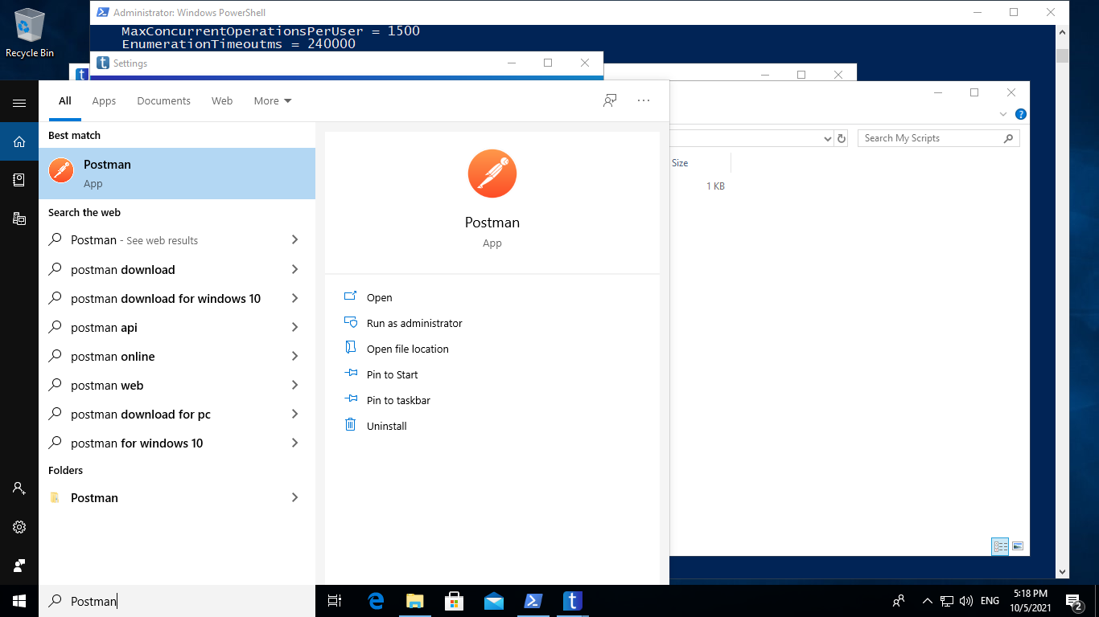

* Now do the below configuration:
  + Set the HTTP methos as POST.
  + Enter the URL ‘http://<host_ip_address>:19312/AwaitScript’.
  + Click on Headers and do set the below key value pairs:
    - Content-Type : text/plain
    - ScriptLocation: <script_dir>\<script_name>.xml
    - Cache-Control : no-cache
  + Click on ‘Send’ button.
  + After few moments, Success status 200 is appeared.

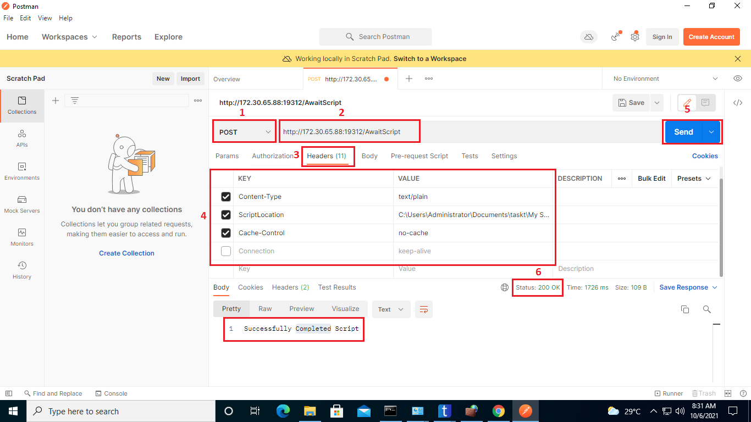

* 1. **Verification:**
     1. **Configure User Profiles:**
* Login to the TaskT Server.
* Enter 'WINDOW+R' key and type 'gpedit.msc' and press ENTER key.
* Navigate Administrative Templates' >>System>> User Profiles.
* Click on 'Do not forcefully unload the users registry at logoff'.
* 'Enabled' must be enabled.

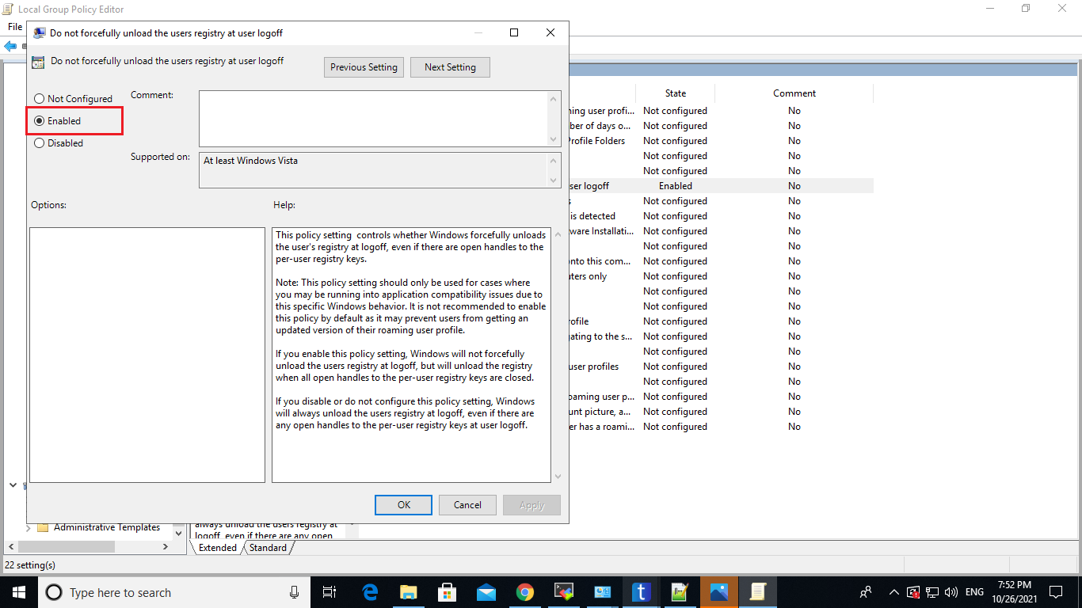

# Chapter 6

**Appendix**

* 1. **Bot script file**
     1. CreateFOlder.xml to create folder: